SIMATS ENGINEERING
ASSESSMENT TOOL 1 - Short Answer Test

COURSE NAME: COMPUTER VISION COURSE CODE: ITA05

COURSE OUTCOME COVERED

CO1: Apply the fundamental concepts, image formation models, and processing techniques for analyzing Computer Vision systems. (BTL 3)

Assessment Tool Weightage: 40%

QUESTIONS
- A self-driving car uses visual input. Write a Python program for lane detection.

- Fine details must be detected in an image. Write a Python program to compare sampling rates.

- An image captured at a low sampling rate shows jagged edges. Write a Python program to demonstrate low sampling effects.

Code of Conduct:

I B. Charan Kumar Reddy (192472195) (Name / Reg No) certify that this submission is my original work and that I have adhered to the guidelines specified for this assessment.
I understand that any violation of academic integrity rules will result in disciplinary action.

Signature of the student:

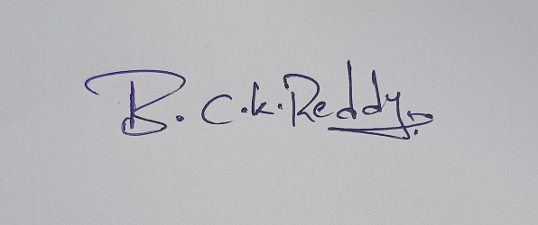

Answers
1.A self-driving car uses visual input. Write a Python program for lane detection.

Code:
import cv2
import numpy as np
image = cv2.imread("road.jpg")
gray = cv2.cvtColor(image, cv2.COLOR_BGR2GRAY)
blur = cv2.GaussianBlur(gray, (5,5), 0)
edges = cv2.Canny(blur, 50, 150)

# Detect lane lines
lines = cv2.HoughLinesP(edges, 1, np.pi/180, 50,
minLineLength=50, maxLineGap=20)
if lines is not None:
for line in lines:
x1, y1, x2, y2 = line[0]
cv2.line(image, (x1,y1), (x2,y2), (0,255,0), 3)
cv2.imshow("Lane Detection", image)
cv2.waitKey(0)
cv2.destroyAllWindows()
Output: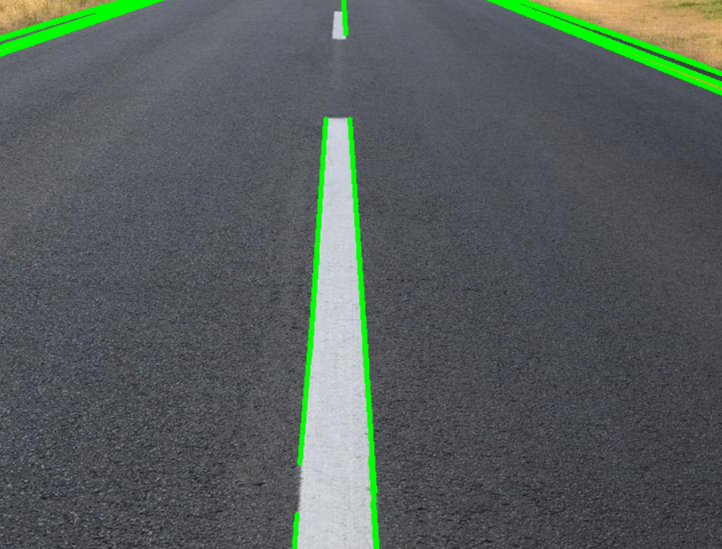
2. Fine details must be detected in an image. Write a Python program to compare sampling rates
Code:
import cv2
image = cv2.imread("image.jpg")
high = cv2.resize(image, (600, 600))
medium = cv2.resize(image, (300, 300))
low = cv2.resize(image, (100, 100))
cv2.imshow("Original", image)
cv2.imshow("High Sampling", high)
cv2.imshow("Medium Sampling", medium)
cv2.imshow("Low Sampling", low)
cv2.waitKey(0)
cv2.destroyAllWindows()
Output:
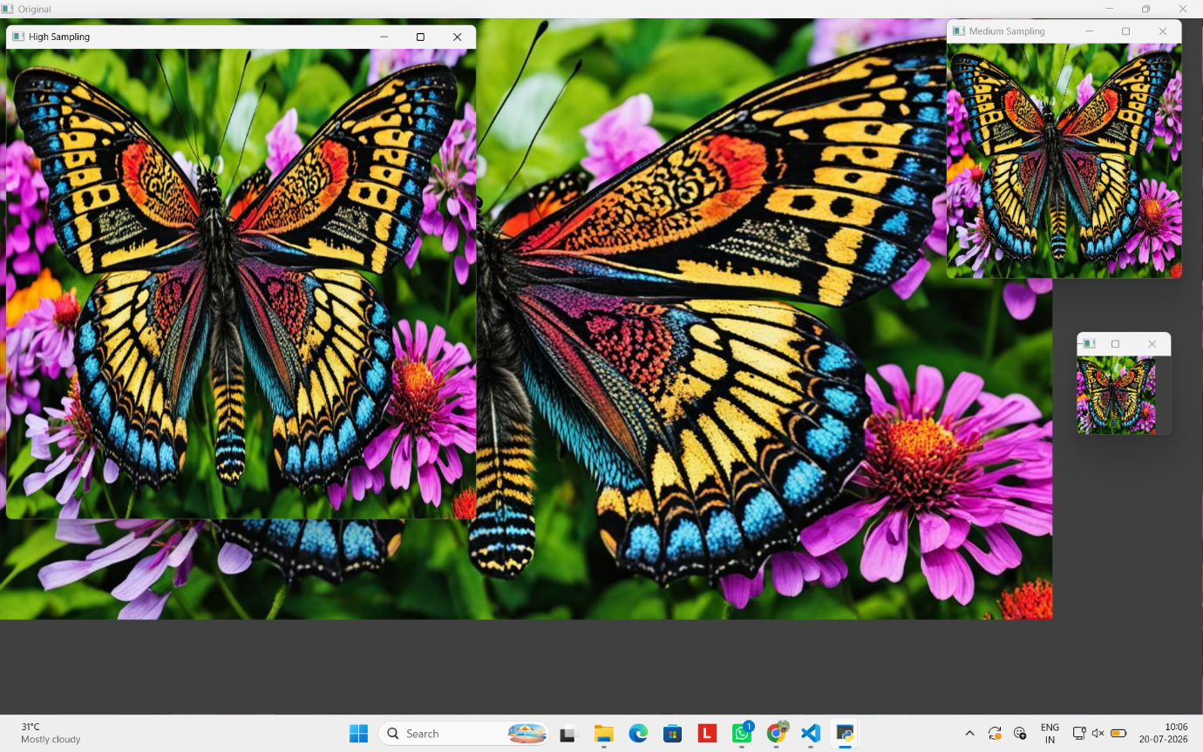

3.An image captured at a low sampling rate shows jagged edges. Write a Python program to demonstrate low sampling effects.
Code:
import cv2
image = cv2.imread("image1.jpg")
low = cv2.resize(image, (80, 80),
interpolation=cv2.INTER_NEAREST)

jagged = cv2.resize(low,
(image.shape[1], image.shape[0]),
interpolation=cv2.INTER_NEAREST)
cv2.imshow("Original Image", image)
cv2.imshow("Low Sampling Effect", jagged)
cv2.waitKey(0)
cv2.destroyAllWindows()

Output:
